Activity 19: Troubleshooting practical
Open Packet Tracer along with the ‘Packet Tracer Troubleshooting Activity.PKA’ file and apply your resolution.
A customer has reported the following issue and is looking for a speedy resolution: Users on Network1 unable to communicate with Network2.
Troubleshoot and resolve this issue.
Note: Remember to save any files once your activity is complete.

Topology
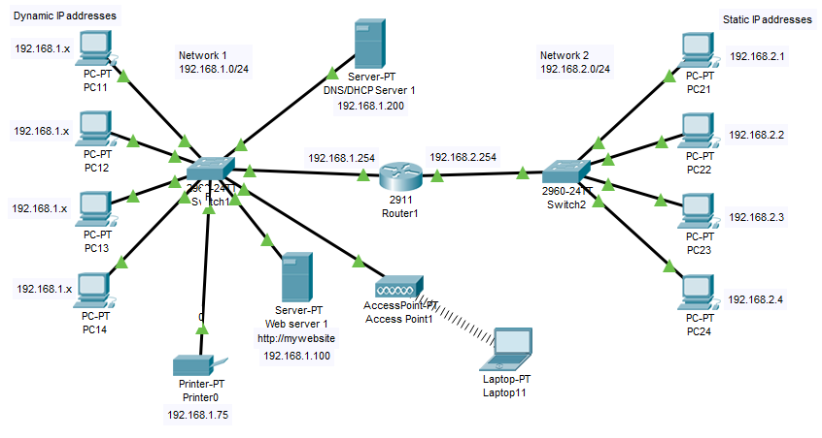

Consider the probable cause of failure (discuss possible scenarios that would create this problem):
- Router misconfiguration,
- Incorrect IP configuration on PC’s,
- NO DHCP/DNS,
- Faulty hardware.
List the actions that could possibly solve the problem:
- ping PC21 from PC11 = no successful reply
- Ping Router from PC12 = no successful reply
- Ping PC14 from PC12= no successful reply
- Did ipconfig on all PC’s in Network 1= got 169.254.212.12 for all PC’s which is APIPA. This is only due to DHCP service issue.
- So checked DHCP server for Service status and it was turned off. Hence needed to turn it on.
- Also, checked for Ip Configurations and Identified Default Gateway was misconfigured to a different IP address i.e. 192.168.2.254 can change IP to 192.168.1.254.
- Renewed IP on all the PC’s in Network 1 checked with Ipconfig, and found valid configurations on all the PC’s.
- Identified that PC13 and PC 14 was statically configured need to be changed to DHCP
- ping PC11 from PC21 = no successful reply
- Ping Router IP from PC11 = successful reply
- Ping PC14 from PC12= successful reply
- Check Router Configurations, and port settings. Identified Gigabyte Ethernet port 0/1 misconfigured to 192.168.3.254 instead of 2.254, so fixed that.
- ping PC21 from PC11 = successful reply
- ping PC22 from PC12 = successful reply
Verify the solution by repeating the tests from the above ticket.
(If the issue persists, undo any changes and return to your list):
- ping PC11 from PC21 = successful reply
- ping PC12 from PC22 = successful reply
Record your solution to the problem. (Your notes can prove invaluable if you encounter a similar issue again.):
- Summarise how did you identify, what was the cause for the failure, how did you do fix it and how did you verify.

